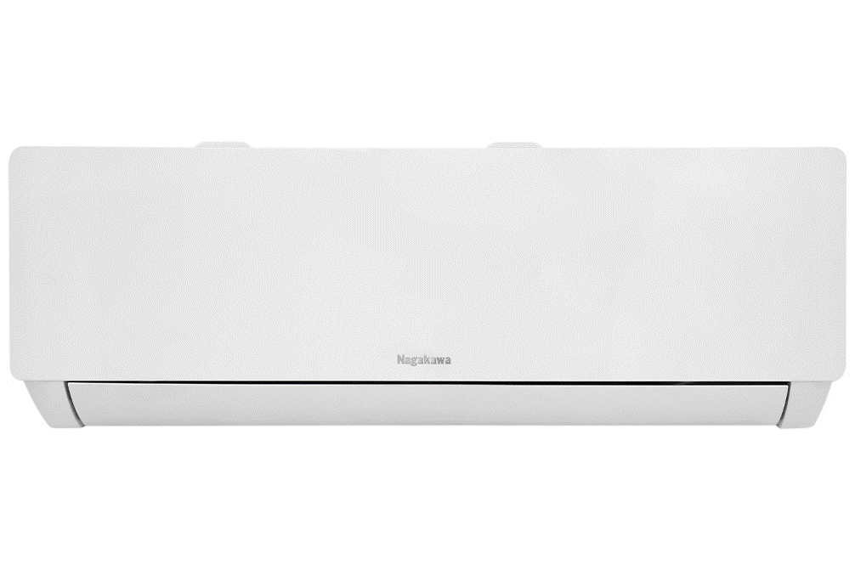

**8,490,000 VND**

(-15%)No copper pipes and supplies will be given away.Delivery only, no installation.

**Technical specifications of Nagakawa Inverter 1.5 HP NIS-C12R2T28 air conditioner**

* Machine Type:

1 way (cooling only) With Inverter

* Cooling capacity:

1.5 HP - 12,000 BTU

* Effective cooling range:

From 15 - 20m² (from 40 to 60 m³)

* Dust filter, antibacterial, deodorant:

6 in 1 filter

* Power saving technology:

EconomyInverter

* Rapid cooling:

Turbo

* Utilities:

Favorite setting mode I-set Sleep operating mode Dehumidification function I Feel temperature sensor Turn on and off timer Temperature display screen on the indoor unit Automatically restarts when power is restored

* Power consumption:

1.25 kW/h 5 stars (Energy efficiency 4.57)

* Cooler:

Length 79 cm - Height 27.5 cm - Thickness 19.2 cm - Weight 8.5 kg

* Outdoor:

Length 74 cm - Height 45.9 cm - Thickness 27.6 cm - Weight 19 kg

Introducing the company 

- Vietnamese brand.  
- Established in 2002.  
- Diverse business products: air conditioners, dishwashers, induction cookers,.... with product prices easily accessible to consumers.  
- Achieved many outstanding achievements: Top 100 best products for families and children (2023), golden brand for Vietnamese health (2019),

[***Nagakawa Inverter 1.5 HP NIS-C12R2T28 air conditioner***](https://www.dienmayxanh.com/may-lanh/nagakawa-inverter-15-hp-nis-c12r2t28)***belongs to the 1-way air conditioner line (cooling only), modern design, compact design, equipped with Economy and Inverter technology to save electricity, antibacterial dust filter and disinfection ability. Good smell with 6 in 1 filter.***

**Design overview**

**Cooler**

- [Nagakawa air conditioner](https://www.dienmayxanh.com/may-lanh-nagakawa) has a luxurious, sophisticated white color scheme, suitable for most home interior spaces.

**Outdoor**

- **Golden Fin pure copper tube radiator** : good corrosion resistance, protects the radiator surface, especially suitable for areas near the sea.

**Refrigeration technology**

- The machine operates with a capacity of  [**1.5 HP - 12,000 BTU**](https://www.dienmayxanh.com/may-lanh?g=15-hp) , suitable for room spaces with an area of **​​15 - 20m² (from 40 to 60 m³)** .

**- Turbo** cooling technology operates with high capacity, capable of quickly cooling according to the set temperature in 20 - 30 minutes, helping you enjoy an instant cool space without spending too much time waiting.

**Power saving technology**

[**- Inverter**](https://www.dienmayxanh.com/may-lanh?g=may-lanh-inverter) technology : with this technology, the machine's performance will be increased, the fan speed will also be changed at many levels for smooth operation, vibration and noise will be significantly reduced, thereby saving money. save energy consumption.

**At the same time, Economy** technology helps reduce power consumption but still ensures to bring you a stream of cool air.

**- The product meets the 5-star** energy label with energy efficiency **of 4.57** .

**Air filtering ability**

- **6 in 1 filter** : effectively cleans the air, removing agents that affect the user's health such as dirt, bacteria, mold,...

**Diverse utilities**

- **I-set favorite setting mode** : users set the family's favorite temperature mode once, every time you turn on the machine, you just need to press "I-set" on the remote and the air [conditioner](https://www.dienmayxanh.com/may-lanh) will automatically operate. Operate according to the previously installed program.

- **I Feel temperature sensor** : this sensor is capable of transmitting signals to the indoor unit about the ambient temperature where the remote is located. Thanks to that, you just need to put the remote next to your body to enjoy the cool air as desired.

- [**Dehumidifying function**](https://www.dienmayxanh.com/kinh-nghiem-hay/cac-che-do-thuong-thay-tren-may-lanh-795107#lam-kho) : has the effect of absorbing moisture in the air, helping the room stay dry and airy.

- [**On/off timer**](https://www.dienmayxanh.com/kinh-nghiem-hay/cac-che-do-thuong-thay-tren-may-lanh-795107#hen-gio) : users can easily turn on/off the device proactively, limiting energy waste when forgetting to turn off the device.

- [**Automatically restarts when there is power**](https://www.dienmayxanh.com/kinh-nghiem-hay/cac-che-do-thuong-thay-tren-may-lanh-795107#tu-khoi-dong) : this function has the ability to remember the previously set mode. When there is a sudden power outage, you do not need to readjust the settings, suitable for use at night. night, does not affect the whole family's good sleep.

- [**Sleep mode**](https://www.dienmayxanh.com/kinh-nghiem-hay/che-do-ngu-dem-tren-may-lanh-la-gi-631348) : when activating Sleep mode on the remote, the air conditioner will automatically operate at low power, minimizing noise to avoid affecting the whole family's sleep.

*In general, the Nagakawa Inverter 1.5 HP NIS-C12R2T28 air conditioner is a suitable choice for room spaces with an area of ​​15 - 20m² (from 40 to 60 m³), ​​the machine operates smoothly, saves energy, and is equipped with advanced technology. Turbo fast cooling technology, antibacterial dust filtering ability with 6-in-1 filter, and equipped with many outstanding utilities such as dehumidification function, on-off timer, automatic restart when there is power,...*